**Task Description#1**

* **Zero-shot: Prompt AI with only the instruction — Write a Python function to generate the Fibonacci sequence up to n terms**

**Expected Output#1**

* **A working function without using any sample inputs/outputs.**

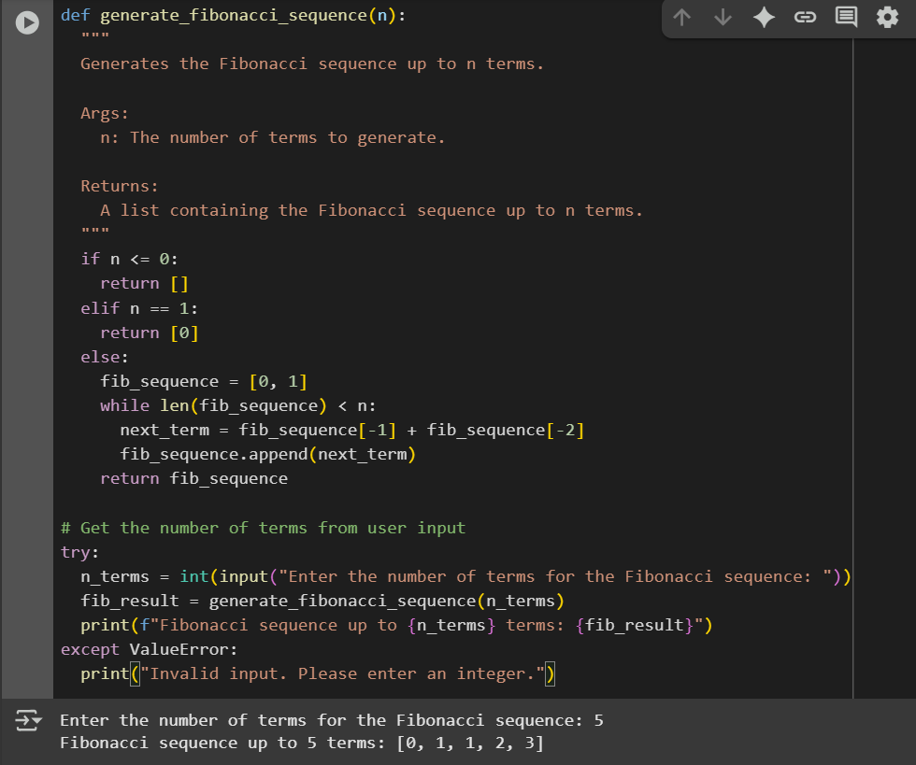

**Task Description#2**

* **One-shot: Provide one example: Input: 100, Output: 37.78 to help AI generate a function that converts Fahrenheit to Celsius**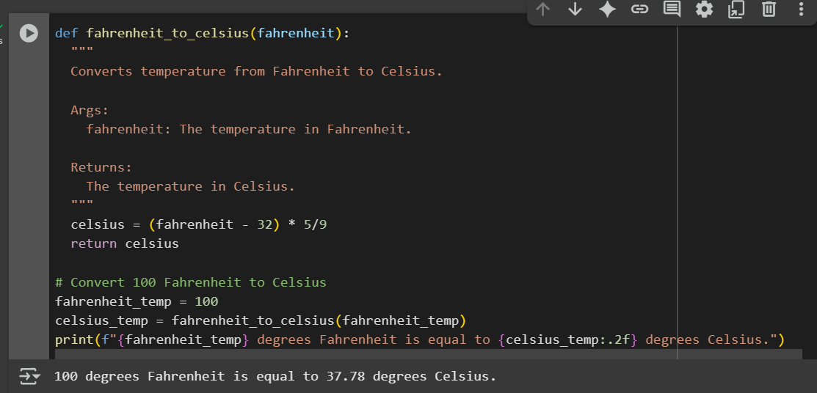

**Task Description#3**

**Few-shot:** Give 2–3 examples to create a function that extracts the domain name from an email address  
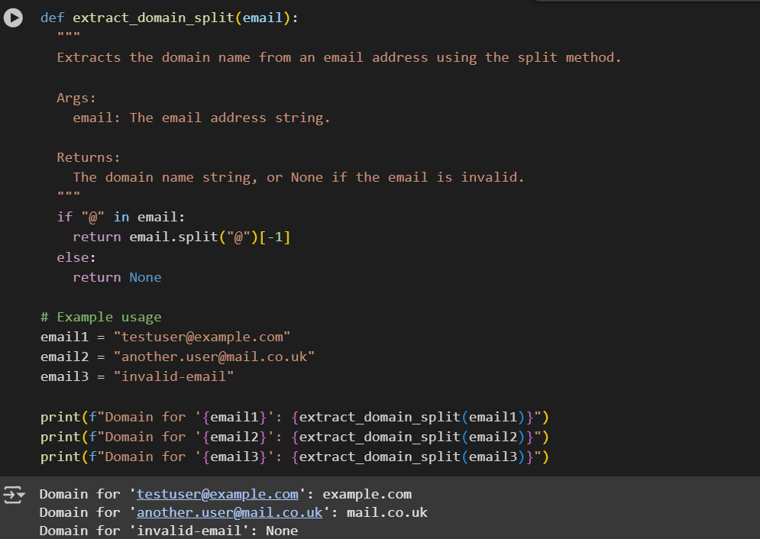

**Task Description#4**

* Compare zero-shot vs few-shot prompting for generating a function that checks whether a word is a palindrome, ignoring punctuation and case.

**Expected Output#4**

* Output comparison + student explanation on how examples helped the model.

|  |  |
| --- | --- |
| ZERO SHOT | FEW SHOT |
| **Zero-Shot**: The model only gets the instruction and complete the only task not giving any examples, but sometimes it misses details. | **Few-Shot**: The model is gives the code with few examples,and trun the code |

**Task Description#5**

* Use few-shot prompting with 3 sample inputs to generate a function that determines the maximum of three numbers without using the built-in max() function.

**Expected Output#5**

A function that handles all cases with correct logic based on example patterns

